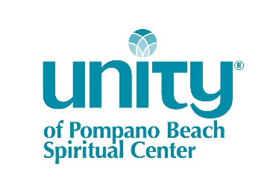
WEDDINGS, HOLY UNIONS AND VOW RENEWALS
UNITY OF POMPANO BEACH SPIRITUAL CENTER
261 SE 13th Street, Pompano Beach FL 33060
954-946-0857
unitypb@live.com

SMALL CHAPEL CEREMONY (MAX. 15 PEOPLE), WEEKDAY/SUNDAY: from $350
- Licensed, ordained officiant to conduct standard ceremony
- Maximum one hour use of chapel on a weekday (M-F) or after 2 pm on a Sunday
SMALL SANCTUARY CEREMONY (MAX. 20 PEOPLE), WEEKDAY/SUNDAY: from $525
- Licensed, ordained officiant to conduct standard ceremony
- Facility staff person onsite
- Maximum one hour use of sanctuary on a weekday (M-F) or after 2 pm on a Sunday
FULL SANCTUARY CEREMONY (MAX. 340 PEOPLE): from $1995
- Licensed, ordained officiant to custom-design your ceremony, conduct a 30-minute rehearsal the day before your wedding, and perform your ceremony on your big day
- Professional pianist/organist to provide 10 minutes of music before the ceremony, processional music, recessional music, and 5 minutes of music as guests leave the sanctuary
- Facility staff person present for setup/rehearsal and ceremony (4 hours)
- Up to two hours’ time in the sanctuary for setup the day before your wedding, which includes 30-minute rehearsal with officiant
- Two hours’ use of the sanctuary on the day of your wedding
- Groom’s waiting area 15 minutes prior to the ceremony
- Bride attendants’ and groomsmen’s waiting area 15 minutes prior to the ceremony
- Convenient off-street parking for 95 vehicles
- Circular drive for your elegant entrance and/or exit
OPTIONS:
- Livestreaming of your event (sanctuary only)
- Use of our white tulle pew bows applied to alternate rows on the sanctuary aisle
- Use of our white carpet (sanctuary only)
- Use your own officiant or musician: no additional charge
- Reception hall rental for 100 people

